ORDER MANAGEMENT FOR PROCESSING CUSTOMER ORDERS

Șutea Adrian

Group 30425

Objective
Consider an application OrderManagement for processing customer orders. The application uses (minimally) the following classes: Order, OPDept (Order Processing Department), Customer, Product, and Warehouse. The classes OPDept and Warehouse use a Binary Search Tree for storing orders.
a. Analyze the application domain, determine the structure and behavior of its classes, identify use cases.
b. Generate use case diagrams, an extended UML class diagram, two sequence diagrams and an activity diagram.
c. Implement the application classes. Use javadoc for documenting classes.
d. Design, write and test a Java program for order management using the classes designed at question c). The program should include a set of utility operations such as under-stock, over-stock, totals, filters etc.

1. 1. Description
The goal of this project is to realize and implement an application that runs a warehouse. The main objective is to analyze the input data and to create structures for stocking them. From the requirements of the project we can deduce some general aspects: the software should use as input data, the clients, the products and the orders.
The application first generates a log in screen, from which it can see if the user is an administrator or a regular user (a client). The administrator is able to add , erase or change the stock of a product and he is also able to see the commands history. The client can search for a product (by name or by price), place one or more commands and see it’s own command history. An order can be made only on a product already existent in the warehouse. The user will be warned if he tries to make an order on a product that isn’t present in the warehouse or if the quantity he wants to order exceeds the stock for that product.
For interactioning with the user, the application has an graphic user interface based on the Java Swing.

Problem analysis
For modelling the application we must determine the entities and the way of implementation. I have identified the next entities that must be implemented in this kind of application:
Customer Class – this class offers the functionality for a specific customer. Instances of this class could be used for creating a complete order. This class contains informations about the customer, like his name. Other informations can be added further.

Product Class – this class retains information about on specific product. The main attributes of a product are: name, quantity and price. The class body also contains getters and setters for accessing each one of the product’s attributes.

Order Class – it’s constructor gets as parameters a quantity and a product and sets them for a new order. It also contains two methods that return the ordered product and the ordered quantity.

OPDept Class – this class is used for processing the orders. It contains two checking methods: one that checks if the ordered product exists in the warehouse and one that checks if the ordered quantity is smaller than the stock of that product. This class also has a place command method that updates the quantity of the ordered product and writes the command in the command history.

Warehouse Class – this is the most complex class of this program. The constructor of this class takes from some files the product name, price and stock and adds each of them to a product, which is then added to a list. This class contains the methods: for adding or removing a product from the warehouse, for updating the stock for a product, for searching a product by name or by price and for verifying if a product exists in the warehouse. There are two other methods in this class which are used by the add, remove and update classes in order to modify the content of the files where the products are initially stored.

Gui Class – it creates the initial log in screen from which the type of user is determined. After the user is determined, this class creates different graphical user interfaces depending on whether the user is an administrator or a regular user.

AdminGui Class – this class is created by the Gui class if the user is an administrator. It contains: buttons for each operation that can be done by the administrator, text fields for the item name, price and quantity and a big text area where the name and quantity for each product is shown. The text area needs to be refreshed after each operation in order for the modifications to be seen on it.

RegularGui Class – this class is created by the Gui class if the user is a regular one (a client). It contains: buttons for each operation that can be done by a regular user, text fields for the item name and quantity that the user wants to order and a big text area where messages are shown (ex: „The requested product wasn't found in the warehouse!”) or if the refresh button is pushed, it will show for each product it’s name and it’s price.

Main Class – this class creates an instance of the Gui class in order for the whole program to be able to run.

More information about the functionality of these classes will be presented in the „implementations details” sections of this document.

Diagrams
The program has nine classes separated into two packages: the gui package and the order package. The gui package contains: the Gui class, the AdminGui class and the RegularGui class. The order package contains: the Customer class, the Product class, the Order class, the OPDept class, the Warehouse class and the Main class.

3.1. UML Class Diagram
The class diagram with the relationships between classes is shown below .
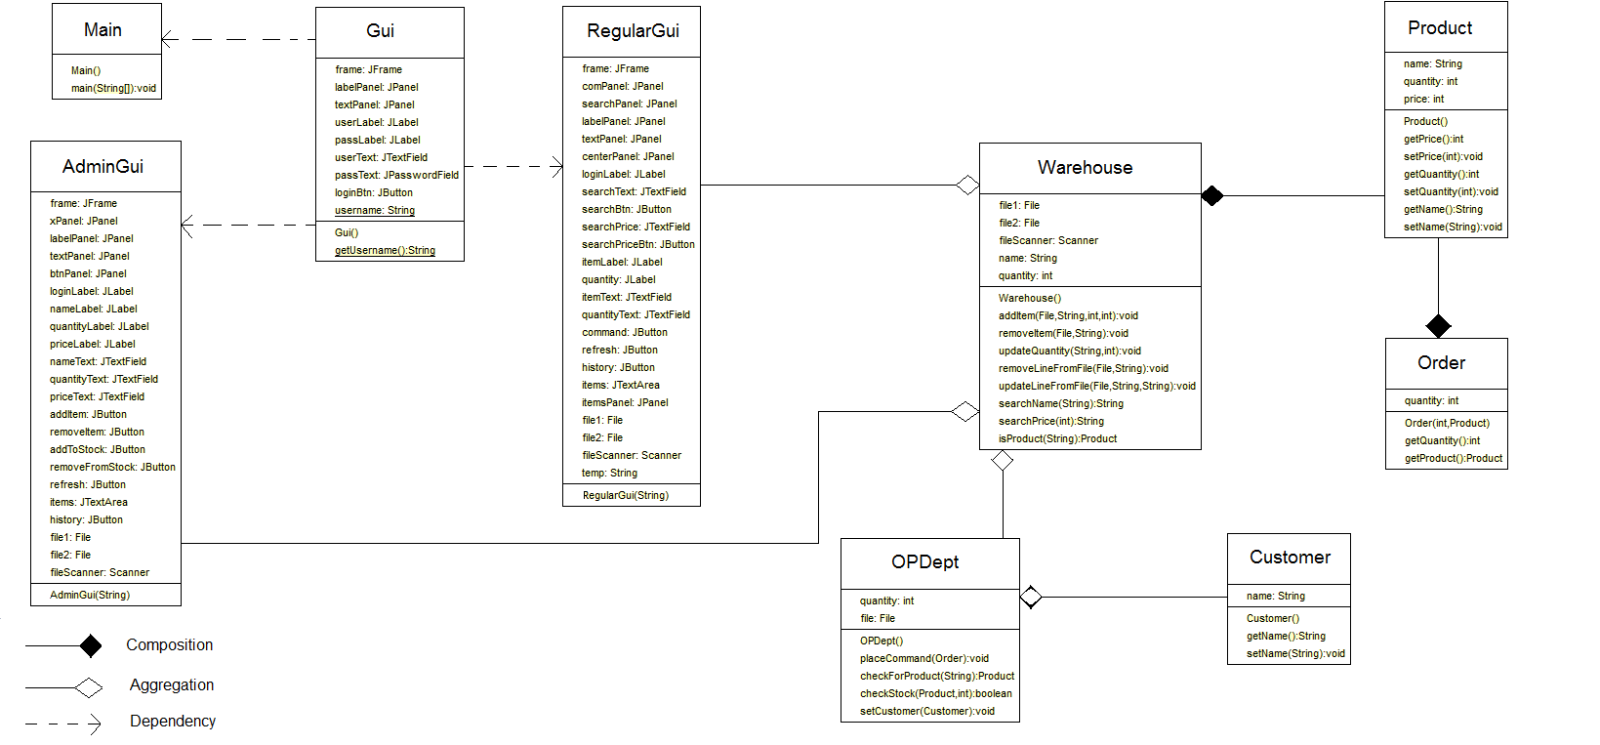

Relationships between classes

The Main class is responsible for creating the Gui class (graphic user interface) and it has a dependency relationship with it. The AdminGui and RegularGui classes have a dependency relationship with the Gui class. The Product class has two composition relationships: one with the Warehouse class and another one with the Order class. There is also a composition relationship between the Customer class and the OPDept class. The Warehouse class is involved in 3 aggregation relationships: one with the AdminGui class, one with the OPDept class and the last one one with the RegularGui class.

3. 2. UML Use-case diagram
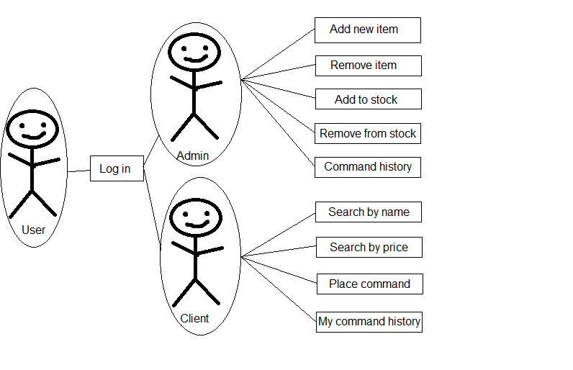
3. 3. UML Sequence diagrams
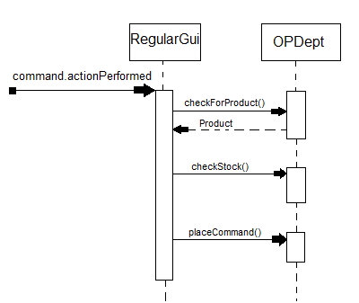

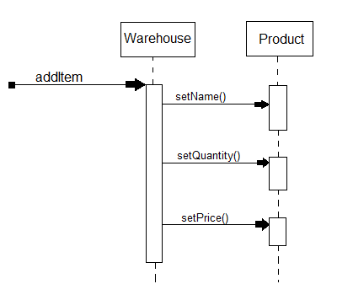

3. 4. UML Activity diagrams
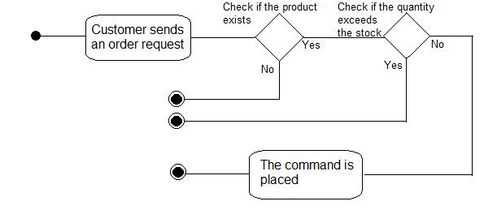

Implementation

4. 1. Implementation and testing
In what the implementation is concerned this project was developed in Eclipse and it was only tested in this environment. However the program should maintain its portability. Concerning the code implementation I did not make use of laborious algorithms, but I have rather stayed faithful to the classical algorithms of computing polynomials learned in high school. However I have tried to implement my problem in a way that appears to me as being the most efficient one, that is why I have changed my model at first. On the subject of this I have decided to use ArrayList instead of arrays because I believe that they are more efficient related to performance and memory management.
Testing implies checking for any errors in the program or limitations of this program. Due to the fact that the program is rather simplistic, they are few errors that might generate this program to work wrong or to stop. This errors are mostly related to the interface. I have assumed that the user reads the instructions from the interface and respects them, otherwise if he enters data with invalid format the program will probably generate some bugs and will stop. Hence this part with checking all the possible scenarios will be seen as future development.

4. 2. Implementation details
Class design:

Customer Class – This class only has as an attribute a string which represents the name of the customer. The methods contained by this class are a getter and a setter for the string.

Product Class – This class has as attributes a string, which represents the product name, and two integers: one which represents the price of the product and one that stores the quantity that is in the stock. The methods contained by this class are getters and setters for all it’s attributes.

Order Class – This class has as attributes a product (the ordered product) and an integer that represents the stores the ordered quantity. The constructor of this class receives as parameters a product and a integer quantity and sets them to the class’s attributes. The methods contained in this class are a getter for the product and one for the quantity.

OPDept Class – This class has as attributes a customer, a product , an integer
representing the ordered quantity and an instance of the Warehouse class.
The checkForProduct method has as parameter a string and it calls a method in the Warehouse class that checks if the given string is the name of a product, if that’s true then the checkForProduct returns that product, otherwise it returns a null.
The checkStock method receives as parameters a product and a quantity and it returns true if the given quantity is smaller than the quantity that is in stock for the given product or false if the quantity is bigger than the quantity in stock.
The placeCommand method receives as parameter an order and it removes the ordered quantity from the ordered product’s stock and adds to the command history file the name of the customer, the name of the product he ordered and the quantity.

Warehouse Class – The constructor of this methods reads from the file, where the products are stored, a line which has a string and an integer, and sets the string as the name and the integer as the quantity of a product, and adds that product to a list.
The method addItem has as parameters a file, a string and two integers, it creates a new product with the string as the name, the first integer as the quantity and the second one as the price, and then it adds the string and the two integers to the given file.
The removeItem method has as parameters a file and a string, and it searches in the list of products for a product with the same name as the given string, if it finds one then it calls the removeLineFromFile method with the file and the string, concatenated with the product’s quantity, as parameters.
The removeLineFromFile method reads each line from the given file and checks if the string given as parameter is equal to the read line, if that is false then it stores the read line in a temporary file stored in the same place as the original file. After all the lines have been read, the initial file received as parameter is deleted and the temporary file is renamed exactly as the original file.
The updateQuantity method gets as parameters a string and an integer and it searches for a product with the same name as the string and adds to the quantity of that product the integer (for removing from stock, the given integer will be set negative), and then it calls the updateLineFromFile method with file name, the old string and the replacement string.
The updateLineFromFile method works the same as the removeLineFromFile method, the only difference is that in the update method, if the string is equal to a read line, then in the temporary file, instead of the read line it is stored another string received as parameter.
The searchName method gets as parameter a string, searches in the product list for the products whose names contain the given string, creates a new string with the names and prices of each found product and then returns it.
The searchPrice method gets as parameter an integer, searches in the product list for all the products with a price smaller or equal to the given integer, creates a new string with the names and prices of each found product and then returns it.
The isProduct method gets as parameter a string, searches for a product with the name equal to the string and if it finds one, it returns the product, if not it returns null.

Main Class – this class creates an instance of the Gui class in order for the whole program to be able to run.

Gui Class – The constructor of this method creates the initial graphic user interface of the program. This interface contains a text field for the user name, a password field for the password and a log in button. If the name written by the user in the text field is „Admin” then the AdminGui is shown, otherwise, if any other name is written, the RegularGui is shown.

AdminGui Class – The constructor of this class creates a graphic user interface special for the warehouse administrator. The interface contains: buttons for each operation that can be done by the administrator, text fields for the item name, price and quantity and a big text area where the name and quantity for each product is shown.
The clicking of the „Add new item” button calls the addItem method from the Warehouse class with the parameters as the string written in the item name text field , the integer written in the quantity text field and the integer written in the price text field.
The clicking of the „Remove item” button calls the removeItem method from the Warehouse class with the parameters as the string written in the item name text field.
The clicking of the „Add to stock” button calls the updateQuantity method from the Warehouse class with the parameters as the string written in the item name text field and the integer written in the quantity text field.
The clicking of the „Remove from stock” button calls the updateQuantity method from the Warehouse class with the parameters as the string written in the item name text field and the negated value of the integer written in the quantity text field.
The clicking of the „Refresh” button will read each line from the file where the items are stored and add them to the big text area.
The clicking of the „Command history” button will read each line from the file in which the history of the commands are stored and add the lines to the big text area.

RegularGui Class – The constructor of this class creates a graphic user interface for the regular user (the client) . The interface contains: buttons for each operation that can be done by a regular user, text fields for the item name and quantity that the user wants to order and a big text area where messages are shown (ex: „The requested product wasn't found in the warehouse!”) or if the refresh button is pushed, it will show for each product it’s name and it’s price.
The clicking of the „Search by name” button calls the searchName method from the Warehouse class with the parameters as the string written in the text field in the left hand side of the button.
The clicking of the „Search by price” button calls the searchPrice method from the Warehouse class with the parameters as the integer written in the text field in the left hand side of the button.
The clicking of the „Place command” button will call the checkForProduct method in the OPDept with the parameter as the string written in the item name text field. If that methods returns a value different from null, then a new order is created with the quantity parameter as the integer written in the quantity text field and the product parameter as the product with the name as the string written in the item name text field, and then the checkStock method from the OPDept is called with the parameter as the integer written in the quantity text field. If the checkStock method returns true then the placeCommand method is called having as parameter the previously created order. If the calling of the checkForProduct method returns null, then in the big text area it will be displayed the following message „The requested product wasn't found in the warehouse!”. If the calling of the checkStock method returns false, then in the big text area it will be displayed the following message „The requested quantity exceeds the stock!”.
The clicking of the „My command history” button will read each line from the file in which the history of the commands are stored and add to the big text area the lines in which the first string is the same as the name of the user.
The clicking of the „Refresh” button will read each line from the file where the prices are stored and add them to the big text area.

Conclusions
The hardest part of this project was working with files, especially the algorithms used for removing or updating the line from a file because each one needed in it’s implementation creating temporary files, which I have never worked before with.
As further developments this application could include:

- The possibility of working with a real data base will reduce considerably the time in which the application answers to a command. Also the time for searching will be decreased considerably.
- There could be added more statistics about the warehouse, a lot of other useful stuff.
- There could be done other facilities for the customers, for example at big orders there could be offered a discount.
- The possibility that a user cand make an acount with an ID an a password, the possiblity that he could logged in with them could be a really nice and useful application.
- The possibility that the products can be sorted after conditions chosen by the customers.
- The possibility for each product to have more characteristics.

Bibliography

http://ddelilah.github.io/pt2016/ - from here I learned how to create a sequence diagram
http://www.tutorialspoint.com/uml/uml_activity_diagram.htm - from here I learned how to create an activity diagram
Youtube.com tutorials

